**DAILY ONLINE ACTIVITIES SUMMARY**

|  |  |  |  |  |  |  |  |  |
| --- | --- | --- | --- | --- | --- | --- | --- | --- |
| **Date:** | **15/06/2020** | | | | | **Name:** | **Manish B Shriyan** | |
| **Sem & Sec** | **8th sem B sec** | | | | | **USN:** | **4AL16CS131** | |
| **Online Test Summary** | | | | | | | | |
| **Subject** | | **SMS** | | | | | | |
| **Max. Marks** | | **--** | | **Score** | | | **--** | |
| **Certification Course Summary** | | | | | | | | |
| **Course** | **Python Foundation with Data Structures & Algorithms** | | | | | | | |
| **Certificate Provider** | | | **AWS** | | **Duration** | | | **3 Hours** |
| **Coding Challenges** | | | | | | | | |
| **Problem Statement:**  **Write C program to calculate Electricity Bill** | | | | | | | | |
| **Status: Solved** | | | | | | | | |
| **Uploaded the report in Github** | | | | | **Uploaded** | | | |
| **If yes Repository name** | | | | | **ManishShriyan** | | | |
| **Uploaded the report in slack** | | | | | **Yes** | | | |

Online Test Details:

Score not received

Certification Course Details:

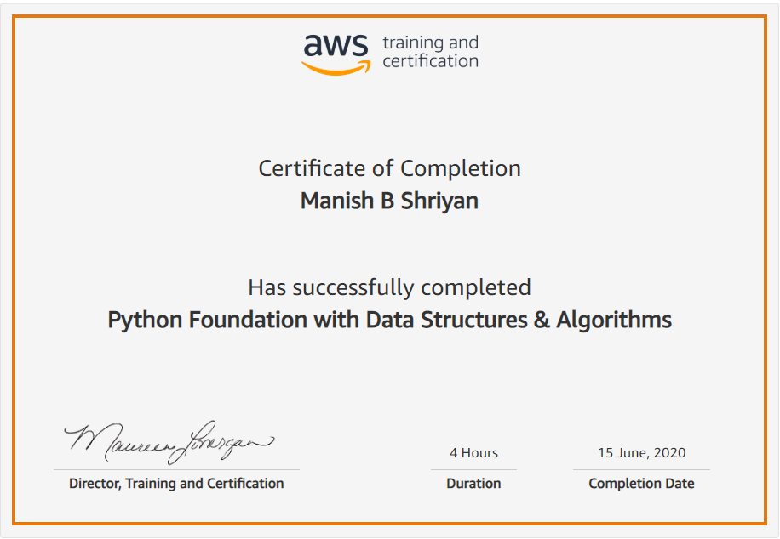

Coding Challenges Details:

|  |
| --- |
|  |
|  |  |
|  |  |
|  |  |
|  |  |
|  |  |
|  |  |
|  |  |
|  |  |
|  |  |
|  |  |

**#include<stdio.h>**

**void main()**

**{**

**int units, cost = 0;**

**printf("Enter no. of units: ");**

**scanf("%d", &units);**

**if (units <= 100)**

**{**

**cost = units * 10;**

**}**

**else if (units <= 200)**

**{**

**cost = (100 * 10) + (units - 100) * 15;**

**}**

**else if (units <= 300)**

**{**

**cost = (100 * 10) + (100 * 15) + (units - 200) * 20;**

**}**

**else if (units > 300)**

**{**

**cost = (100 * 10) + (100 * 15) + (100 * 20) + (units - 300) * 25;**

**}**

**printf("Cost: %d", cost);**

**}**

**N)**